To: | Finance and Performance Panel
Date: | 06 December 2023
Report of: | Head of Financial Services (Section 151 Officer)
Title of Report: | Background and Implications of Local Authority Section 114 Notices

Summary and recommendations
Purpose of report: |  | To update the Finance and Performance Panel on the background and implications of the series of local authority Section 114 notices which have been issued recently and how Oxford compares to those local authorities and others across the country.
Corporate Priority: |  | All
Policy Framework: |  | Council Strategy 2020-24
Recommendation(s): That the Panel resolves to:
1. | Note and comment on the contents of the report and agree any recommendations.

Appendices
Appendix 1 | Summary of Circumstances Cited for Local Authorities Issuing Section 114 Notices

Introduction
- At its meeting on 06 September 2023, the Finance and Performance Panel requested a report to its next meeting from the Head of Financial Services setting out the implications of the series of local authority Section 114 notices which had been issued recently, to include a sense of how Oxford compared to those local authorities and others across the country.
- This report provides an overview of Section 114 notices which have been issued to date and commentary on how Oxford City Council is performing in relation to a number of recurrent themes within those authorities which have issued Section 114 notices.

Legislative Framework
- Local authorities are required by law to set a balanced budget for each financial year. This means that forecast expenditure and forecast income must align; this can include using reserves to balance the budget. Legally, any budget deficit must be balanced.
- The Section 151 Officer of a local authority has a legal obligation to report where that authority has, or is about to, breach the legal requirement for a balanced budget. This is referred to as a Section 114 notice under the Local Government Finance Act 1988 and indicates that the authority’s forecast income is insufficient to meet its forecast expenditure. A Section 114 notice is also required to be issued where an authority has made, or is about to make, a decision which involves that authority incurring expenditure which is unlawful (e.g. using Capital funds for Revenue expenditure).
- A Section 114 notice puts spending controls in place and prohibits all new expenditure by a council, other than that required to provide statutory services such as education services, children's safeguarding and social care, waste collection, planning and housing services, road maintenance and library services. New expenditure may only be authorised by the Chief Financial Officer where it will prevent the situation that led to the s114 notice from getting worse, improve the situation, or prevent its reoccurrence.
- Full Council must meet within 21 days to discuss the Section 151 Officer’s report. Generally those councils in receipt of such notices would seek to pass an amended budget reducing spending on services.
- Section 114 notices are often described as an authority declaring bankruptcy, but a UK local authority cannot become bankrupt. A Section 114 notice simply indicates that the council is about to incur expenditure that is unlawful under the Local Government Finance Act 1988.
- In extreme situations the Secretary of State (as in the case of Birmingham City Council for example) can appoint commissioners to take control of the authority for a period of time – Section 15 of the Local Government Act 1999. This can be full or partial (specific service areas) intervention.
Role of Section 151 Officer
- The role of the Council’s Section 151 Officer as the ‘officer responsible for financial affairs of the authority’ is pivotal in ensuring appropriate financial due diligence and governance within the authority, making decisions in line with their fiduciary duty and in accordance with the principles within the Chartered Institute of Public Finance and Accountancy (CIPFA) Codes and proper accounting practice.
- There will however always be an element of judgment of the individual based on their experience, individual integrity and understanding of the situation. The issuing of a Section 114 Notice will be one of the most critical decisions the Section 151 officer will make in their career and one which will have a long lasting impact on the authority. It is therefore not to be taken lightly.
- In coming to a decision as to whether a Section 114 Notice should be issued the Section 151 Officer has a statutory duty to consult with their fellow statutory officers, the Head of the Paid Service and the Monitoring Officer. In some situations, a s114 report may lead to the issuing of a s5 report by the Monitoring Officer, which is when the council has acted, or is about to act, unlawfully. This was seen in the case of Birmingham City Council.
- Guidance contained within the CIPFA Financial Management Code clearly states that the ‘issuing of a Section 114 Notice should be seen as a ‘last resort’. During the COVID-19 pandemic the Department for Levelling Up Housing and Communities (DLUHC) was advising authorities considering issuing such a Notice, arising from financial losses, should consult with them before doing so, such was the concern for the authority and the sector that this would have.
- In the good old days, it was often said that when a Section 151 Officer issues a Notice, they should ‘pick up their hat and coat on the way out’ however in recent times the reasons for the decisions made by the Section 151 Officer issuing a Section 114 Notice have been more openly understood. Historically, Section 114 notices were more often than not a result of financial mismanagement; more recently the reasons are more varied and complex, resulting from risk-based decisions taken by authorities in light of reducing budgets and the need to continue to meet rising demand for statutory services.
Overview of Section 114 Notices
- Between 2000 and 2018 no local authorities issued a Section 114 Notice, however there have been 11 issued since 2018 with a number of other local authorities warning it is a real risk for them also.
- The London Borough of Hackney issued one in October 2000. This Section 114 notice related to a gap of up to £15.5m in the General Fund and £2.2m overspend on the Housing Revenue Account (HRA). Particular service areas of concern included Waste Management and Revenues and Benefits, which were each £3m overspent; and Transport Services which was £600k overspent.
- The Section 114 notices issued since 2018 are as follows:

Local Authority | Date Section 114 Notice Issued
Northamptonshire County Council | 02 February 2018
Northamptonshire County Council | 24 July 2018
Croydon Borough Council | 11 November 2020
Croydon Borough Council | 02 December 2020
Slough Borough Council | 02 July 2021
Nottingham City Council | 15 December 2021
Northumberland Council | 23 May 2022
Croydon Borough Council | 22 November 2022
Thurrock Borough Council | 18 December 2022
Woking Borough Council | 07 June 2023
Birmingham City Council | 05 September 2023

- A summary of the main circumstances cited for each of the authorities listed above issuing a Section 114 notice is summarised at Appendix A. It is interesting to note that a key theme for these authorities is excessive borrowing that has become unaffordable. When times were good this borrowing was, in most cases, paying for itself and delivering a surplus to be ploughed back into services allowing these authorities to avoid taking the difficult decisions that were being taken elsewhere.
- An increasing number of other local authorities have announced that they are at risk of having to issue a Section 114 notice, including Hastings Borough Council, Stoke-on-Trent City Council, Southampton City Council, Guildford Borough Council and many others across the country. Coventry City reportedly wrote to the Secretary of State Michael Gove, warning ‘local government stands on the precipice of a disaster’.
- A recent survey of Municipal authorities found that 47 authorities feared having to issue a Section 114 notice this year and a further 9 next year.
Analysis
- When considering the circumstances behind local authorities issuing Section 114 notices, a number of recurrent themes emerge. These broadly relate to:
- Poor, or lack of financial controls/management at senior officer and councillor level
- Poor governance practices, processes and structure
- Complex and/or company arrangement. This includes governance and issues in relation to the management and scrutiny of council-owned companies, including institutional blindness to the issues arising
- Poor and failing relationships between councillors and senior officers
- Long standing errors in charging to the appropriate account (i.e. Capital vs Revenue)
- Public Works Loan Board (PWLB) Borrowing and loans being used by council-owned companies
- Incorrect calculation of Minimum Revenue Provision (MRP), often over a prolonged period of time
- Undelivered savings
- Risks associated with ongoing external audit of accounts
- Lack of unallocated reserves

- Most of the local authorities which have issued Section 114 notices to date are Tier 1 authorities, although Woking and Thurrock are tier 2 and a number of other tier 2 authorities such as Hastings and Crawley have been suggesting they may do so. District councils do not have responsibility for services such as Adult Social Care and Children’s Social Care, which are often the source of significant budgetary pressures.
Government Response
- In response to the escalating number of local authority failings in July 2023 the Government established the Office for Local Government (OFLOG), a new performance body for local government, which will provide authoritative and accessible data and analysis about the performance of local government and support its improvement. In a policy paper established in July 2023 they set out their plans to strengthen the overall system such as introducing new statutory best value guidance and improving capacity and capability of the sector. OFLOG intends to work alongside local government to introduce these changes bringing with it increased accountability, transparency with meaningful and insightful data. They point out that this is not a recreation of the Audit Commission (which some in the financial profession would see as not such a bad thing) which in their view was over-regulating and micromanaging.
- In October 2023 OFLOG wrote to authorities seeking views on a range of metrics that they would be using to determine local authority performance. They are specifically trying to address:
- Spotting the warning signs of financial failure in local government
- Tackling missed opportunities for organisational improvement
- A number of key themes to focus on have been chosen:
- Mayoral Combined Authorities
- Roads
- Business and Economic Growth
- Waste Management (fly tipping)
- Planning
- Corporate and Finance – four areas of focus are being consulted upon:
  - The total of a local authority’s debt (including credit arrangements) as compared to the financial resources at the disposal of the authority.
  - The proportion of the total of a local authority’s capital assets which is investments made, or held, wholly or mainly in order to generate financial return.
  - The proportion of the total of a local authority’s debt (including credit arrangements) in relation to which the counterparty is not central government or a local authority.
  - The amount of minimum revenue provision charged by a local authority to a revenue account for a financial year.
25 The Chartered Institute of Public Finance and Accountancy issues a set of comparative performance indicators that measure the resilience of the council and enables comparison with other local authorities. These indicators are based on historical information and a number are not entirely relevant. For instance the interest cover ratio compares general fund income to total debt. For an authority like Oxford with no General Fund external borrowing, but with HRA external borrowing which is financed from rents this has limited value.
Focus of the Issues
- Appendix A highlights some common themes that would have contributed towards the issuing of a Section 114 notice. In assessing whether Oxford City Council will be issuing a notice any time soon it may be appropriate to examine these issues in relation to the Council.

- Financial Management and Controls
The Council has had a good record of financial management. Budgets are prepared in the short and medium term on a 4-year rolling basis. The budget is balanced in each year with a prudent use of reserves, something which many authorities strive for, but few seldom achieve. A 4-year Medium Term Financial Strategy (MTFS) whilst not a legal requirement is deemed good practice since it facilitates long term financial planning and the prudent use of reserves, indicates sustainability of the organisation and supports the demonstration of ‘going concern’ to the external auditors and other interested parties. Supported by the Corporate Management Team (CMT), the Section 151 Officer ensures the robustness of the budget setting process in maintaining this balanced position. Reports on this and also the levels of reserves, are included within the Section 25 report presented each year to Full Council.
Budget monitoring is reported to the CMT on a monthly basis and to Cabinet on a quarterly basis. In the past no major variances to budget have arisen although the impact of COVID-19 in 2020-21 and the resulting tail-off in 2021-22 impacted the Council’s finances quite significantly as illustrated below. This year, 2023-24 has seen the emerging national problem of homelessness which has created a deficit in the revenue budget of approximately £1million which officers are working to mitigate. It is also true that the Council struggles to prevent slippage in the capital programme partly due to size of the programme and the development nature of the projects, but also due partly to the over-optimism of officers when they are setting capital budgets. It is an issue which officers are working to address.

Service Revenue variations to budget – 2020-21 to 2023-24

 | Original Net Service Expenditure | Revised Net Service Expenditure | Actual Net Service Expenditure | Variance | Variance
 | £'000 | £'000 | £'000 | £'000 | %
2020/21 | 30,291 | 27,729 | 33,688 | 5,959 | 21
2021/22 | 35,794 | 34,978 | 39,309 | 4,331 | 12
2022/23 - Estimate | 34,225 | 32,559 | 33,224 | 665 | 2

Capital variations – 2020-21 to 2023-24

 | Original Budget | Revised Budget | Actual | % Actual spend v Original Budget | % Actual Spend v Revised Budget
 | £'000 | £'000 | £'000 | £'000 | £'000
2020/21 | 142,569 | 78,754 | 68,780 | 48.24% | 87.34%
2021/22 | 185,382 | 105,349 | 80,710 | 43.54% | 76.61%
2022/23 | 210,980 | 102,502 | 75,815 | 35.93% | 73.96%

High levels of inflation still persist so the cost of the capital programme is increasing and capital schemes that were previously financially viable, no longer are.
The value of our property investments and multi-asset funds (cash, bonds and stocks and shares) have fallen considerably over the last year, eroding the principle value. Although these funds have achieved (and continue to achieve) significant financial return in excess of bank rates, the principle values have fallen considerably.
We are entering the discussions for the balancing of the MTFP for the next 4-year period with continued reliance on our income stream from our wholly owned companies and financial returns from our investment assets and car parking which once were reliable and are now more problematic. Assumptions around pay and the leisure futures programme have yet to be clarified and some difficult decisions involving service reductions may need to be taken by Members this year if we are to remain in a financially stable position. Difficult decisions not taken this year could have a material impact on the ability of the Council to balance future years.
The Council’s internal audit is undertaken by an external audit team, BDO. In their Annual Report and Statement of Assurance presented to the Audit and Governance Committee in July 2023, the auditor provided a ‘Moderate Assurance that there is a sound system of internal control, designed to meet the Council’s objectives and that the controls are applied consistently’. This was the same assurance as in previous years. In putting this into perspective the auditor advised that very few authorities received substantial assurance and it was noted that a number of audits undertaken for the Council had received substantial assurance for design and/or effectiveness of controls on a number of audits. In 2022-23 there were 34 recommendations issued, 5 high, 16 medium and 13 low, in comparison to 2021-22 where there were 40 recommendations 5 high, 26 medium and 9 low. In 2023-24 officers implemented all outstanding recommendations made in previous years.
In terms of external audit opinion at the time of preparing this report the auditor had still not completed the 2021-22 audit of accounts (see below).
- Strong Financial Management and Good Governance (including in relation to Council-owned companies)
Financial Management in terms of how the organisation collects income, pays its suppliers, monitors and controls financial information is driven by the Financial Services Team headed by the Councils Section 151 Officer. In addition to fortnightly meetings with the other statutory officers, (the Chief Executive and Monitoring Officer), the Section 151 Officer is also a member of the Council’s Corporate Management Team (CMT).
The Council’s wholly owned companies OX Place and Oxford Direct Services as part of the Council Group are an integral part of the Council’s business, supplying dividends back to the Council to support the financing of its services. Financial and governance oversight by the Council, the Section 151 Officer and the Monitoring Officer is exercised through company’s attendance at CMT and the Shareholder meetings with the Company. The two can be interlinked and failure in both, in the case of Nottingham and other councils, materially contributed to the issuing of a Section 114 notice.
Whilst wholly owned companies are becoming more prevalent in local authorities they are still relatively new ground for local authorities. Our wholly owned companies are forecast to deliver approximately £30million in dividends over the next MTFS and are essential to the Council if it is to continue to maintain services. Regular review of the Companies’ governance is a key area of focus for the Audit and Governance Committee and the Council’s Monitoring Officer and a review is commencing in relation to the Council’s governance of its wholly owned companies.
A number of audits have been undertaken over the years by the Council’s internal auditors, BDO, who have generally given the Council moderate assurance over the governance arrangements over our wholly owned companies. The Shareholder group meets regularly with the companies and the shareholders are advised by its officers, and the Council’s Section 151 Officer provides independent commentary on reports coming to Shareholder group and other Members scrutinise the work of the companies. Local authority directors sit on the company boards and although they have a statutory requirement to act as director of the company when sitting on the board, they can at least provide a Council viewpoint of the implications for the Council of company board decisions. Whilst this is new ground and the authority can always improve, the governance of such companies is for the time being in a stable position.
- Processes for charging to Capital/Revenue
Capital expenditure is defined in the CIPFA Accounting Code of Practice as:
All expenditure relating to cost of acquisition, creation or purchase, plus any expenses directly attributable to bringing the asset to the location and condition necessary for them to be capable of operating in the manner intended by management, that can be directly attributed to items of property, plant and equipment or the acquisition of rights over certain longer-term intangible benefits plus any subsequent expenditure on these that results in future economic benefits or service potential associated with the item flowing to the authority
Charging expenditure over a longer period is obviously attractive in the current financial climate and it is often an area which is subject to much audit scrutiny over the years. In fact in the audit Terms of Reference the auditors describe unlawful capitalisation as ‘fraudulent’ emphasising the seriousness of the issue. The authority has a significant capital programme (approximately £235 million original budget for 2023-24) and non-capital items that should be charged to revenue sometimes arise, but are picked up by the Finance Team and reversed to revenue. Significant charges are also made for salaries of officers employed on capital scheme with approximately £1.2 million budgeted for 2023-24. This is an area where professional judgement has to be applied and the costs charged to capital are scrutinised to ensure that they are incremental costs and that the person being charged to a capital project makes an identifiable and measurable contribution to the physical development of property, plant or equipment. In short salaries can only be charged to capital if ‘the salary would not have been incurred if the project had not gone ahead’. Whilst it is not possible to say that 100% of non-capital items are picked up and corrected, there is a sufficient level of scrutiny to ensure that all material items are properly charged and I am satisfied that we apply the principle in accordance with the Accounting Code of Practice.
- Charging to the HRA
Income and expenditure credited and debited to the HRA is governed under the 1985 Housing Act and further defined by DoE circular 8/95 which has subsequently been replaced by DLUHC Guidance “Operation of the Housing Revenue Account ring-fence” published 10th November 2020. There can be a temptation to use the HRA to subsidise the General Fund (as in the case of Nottingham City Council) which is against the requirements of the Code and is unlawful. Where income and expenditure relates to a mix of general fund and HRA activity, professional judgement must be applied to determine the correct apportionment; an example of this is staff time which is allocated through recharges. The interaction of the Housing Company with the HRA and the General Fund is sometimes a subject of debate as we try to ensure that the HRA is no worse off than any other landlord in the purchase and operation of social dwellings for its tenants. I am generally satisfied that the council does make appropriate credits and debits to the HRA in accordance with legislation and guidance.
- Local Authority Borrowing/ Lending to Council-owned companies
The Capital Financing Requirement (CFR) for a local authority is described as the ‘underlying need for the authority to finance capital expenditure by borrowing’. It is important to note that the borrowing may be in the form of ‘internal borrowing’ i.e. using existing balances and reserves or external borrowing which would be typically from Public Works Loans Board (PWLB). In Oxford (apart from £198 million of external HRA debt, taken out for self-financing in 2012) the authority currently has no external borrowing. The CFR and the external debt position over time is as shown below (from the Treasury Management Strategy 2023/24 which is based on the budgets set in February 2023):

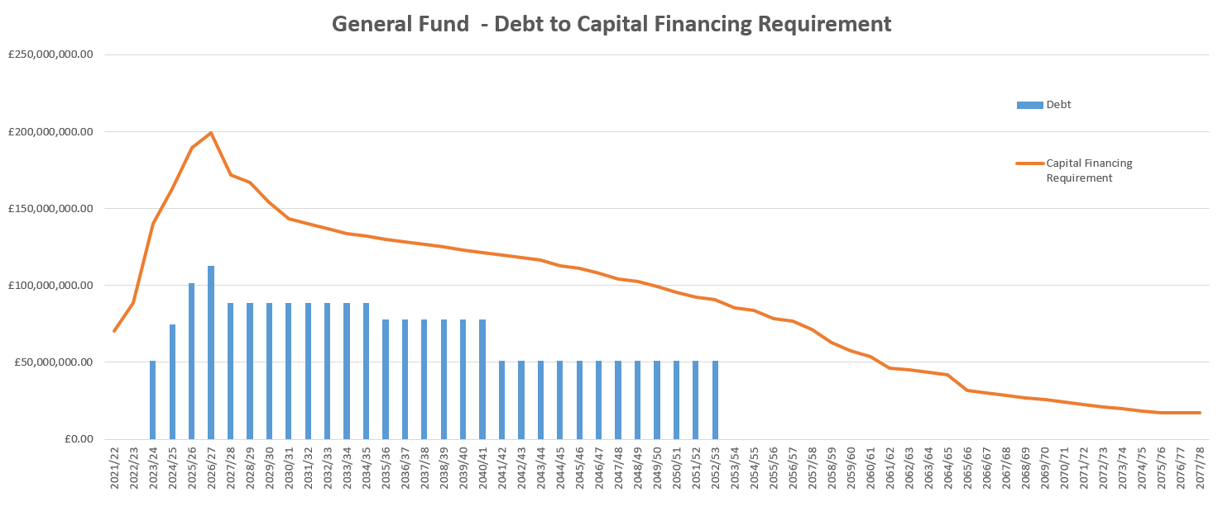
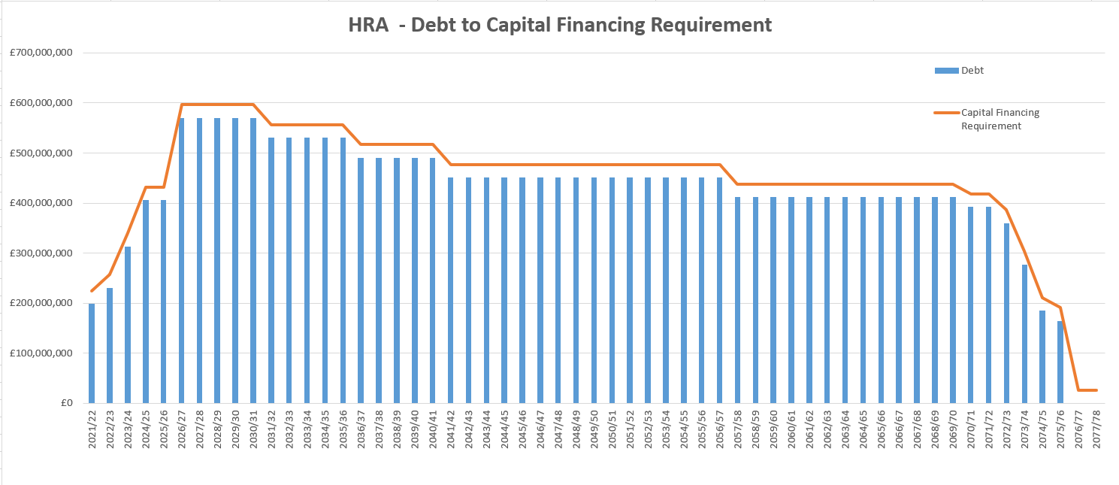

The charts above indicate that:
- General Fund - based on current capital plans, will repay external debt by 2052/53 and that the underlying need to borrow (the Capital Financing Requirement) reduces over time through the repayment of debt from the companies and the application of Minimum Revenue Permission (MRP). This demonstrates proper management of the General Fund borrowing needs;
- HRA -debt follows its Capital Financing Requirement (CFR) with a consistent amount of internal borrowing (which arose on the transfer of the HRA garages and shops to the General Fund). The HRA does not have to make an MRP, however in order to reduce its CFR in line with the debt repayment there would need to be a charge to revenue (a Voluntary Revenue Provision). The graph assumes that sufficient revenue balances are built up in order to allow repayment of debt, however due to the nature of the HRA and the asset-based nature of its service, there will always be a need to incur capital expenditure and so rather than repaying debt, a decision may be made to re-borrow the funds. This is a normal process for the HRA.
This situation of using internal borrowing is estimated to last for some time although at some point the council will externally borrow at which point the risk will be increased. Whist the borrowing is used to fund schemes across the programme the largest allocation is in respect of lending to OX Place both the Investment Company and the Development Company. Estimated lending over the years is shown below:
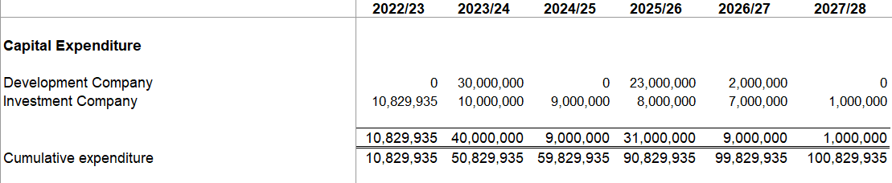
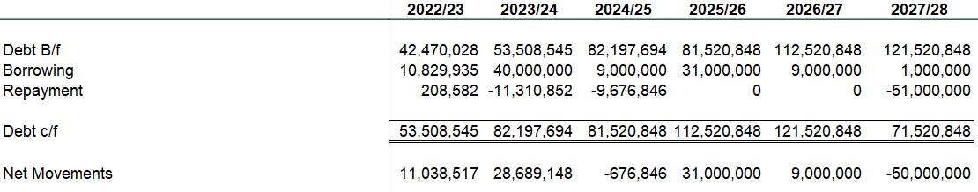

There are risks in these transactions, more so on the loans given on developments, since loans to the investment company are to a large extent covered by the value of properties (currently specifically from Barton) that the loan is given for. The loan to asset for the investment company is currently running at around 91.9%. In respect of the development company the risks are higher especially in the days before the company achieved profitability, which has only just occurred. Covenants which control the amount of borrowing by the company such as interest cover ratio, asset cover and profitability are being discussed with the company but are yet to be agreed.
Other schemes for which borrowing has been used as finance include Oxwed (£6.5 million of the £13 million of loans given to date). The scheme is currently being prepared planning approval and although there is still a way to go it should deliver a healthy surplus back to the Council and its partner Nuffield College. Recently plans have been approved by Council to develop the Odeon site which will also be financed by borrowing and although the ‘heavy lifting’ of the scheme will be undertaken by a development partner, this will bring with it development risk, which is balanced against the delivery of a regenerated area of land within the city centre.
In all these schemes the Council relies on the experience and professionalism of the team within both the Housing Company and the Council to deliver the schemes which enables the repayment of the loans. The risk will never be removed given that this is development, but it may be mitigated by monitoring and oversight which is undertaken by both officers and shareholders.
- Minimum Revenue Provision Calculation
Minimum Revenue Provision (MRP) is the accounting term used to describe the method by which local authorities charge their revenue accounts over time, with the cost of their capital expenditure which is funded by borrowing (be it internal borrowing from reserves and balances or external borrowing from the Public Works Loans Board (PWLB). Generally the borrowing is charged over the useful life of the asset that is financed, so a property purchase may for instance be charged over 50 years. The requirement to undertake this calculation is a requirement of the CIPFA Accounting Code of Practice and also the Government’s Statutory Guidance On Minimum Revenue Provision (made in accordance with section 21(1A) of the Local Government Act 2003. The Finance Team are diligent in ensuring that the correct calculation is applied and is used in capital scheme appraisals. This often leads to tensions internally because it can affect the viability calculations and therefore the affordability of schemes since it increases the costs of a project. It is right and proper to include MRP in capital scheme appraisals since it is a cost which will impact the Council’s revenue account if the project in question is completed. It is surprising to see the number of authorities in appendix A that do not apply this correctly and this is often the subject of an auditor’s scrutiny.
- Unachieved Savings
In previous years the council has had a good track record of delivering savings. Contingencies were held for any savings that the council has failed to achieve. As the financial backdrop gets more difficult savings targets have become more difficult to achieve. In 2022-23 for instance the council set itself a target of £2.351 million achieved £2.301 million. In 2021-22 the council set a target of £1.803 million and achieved the target.
In 2023-24 the target set was £1.993 million and current forecast is that only £1.103 million will be achieved. Reasons for variation include slippage on achieving the re-letting of St Aldates Chamber (£641k), Procurement Savings which has only achieved around £38k per annum against a target of £100k and unachieved savings in staffing levels due to changes in the Customer Contact Centre.
The Organisational Change Board established by the Council will provide future scrutiny and oversight of benefits and cashable savings, although 100% achievement may be an overly optimistic achievement.
- Risks associated with ongoing external audit of accounts
Up until 2021-22 the Council had a good track record of Statement of Accounts preparation. No qualification of the accounts had been made by the auditors in the last 10 years or so and their reports to the council generally praised the work of the Finance Team. The problematic implementation of the Housing Management System has been well documented, with ‘steady state’ not being achieved until November 2022, following ‘go live’ in April 2021. This subsequent lack of financial information has been a setback, resulting in a delay in the filing of the ODS 2021-22 company accounts at Companies House until 15th August 2023 and the 2022-23 company accounts have yet to be signed off by the auditors. As a consequence the Council have fallen behind with the preparation of its own Group accounts for 2021-22 and single entity and Group accounts for 2022-23. The knock on impact is uncertainty over the level of reserves and unused capital receipts impacting on financial planning. Whilst we would like to be fully up to date by the time the 2023/24 accounts should be being prepared, given the level of work required and the level of audit scrutiny this is uncertain, so for the time being this remains an issue.
- Reserves
The prudent level of reserves that the Council should maintain is a matter of judgement. Generally the higher the risk of the council’s financial plans the higher the level of reserves and balances. The Oxford Model’s reliance on income streams from its wholly owned companies and other sources of income such as commercial rents is more of a risk than simply reducing spend. In such situations it is prudent and advisable to hold an adequate amount of reserves and balances to deal with any volatility in these area.
CIPFA undertake a survey of councils to understand their financial resilience. By analysing data from individual councils and providing comparisons on a number of key financial areas, CIPFA place a risk rating against each of these measures in terms high, medium and low risk. The latest exercise was undertaken in December 2022 based on financial information for 2021-22.
The main observations in comparison to other non-metropolitan districts was as follows:
- The ratio of Council tax income as a proportion of net expenditure was 38% for Oxford against a range of 34%- 100% for other local authorities. The authority was deemed low risk.
- The ‘Oxford Model’ relies on significant income streams to fund its gross expenditure. Fees and charges as a ratio to service expenditure is 25% against a range of 1.37% to 57% for other local authorities. This ratio will increase over the life of the MTFP given the reliance on financial returns from OCHL and ODS and although deemed low by CIPFA is certainly one to closely monitor.
- The high percentage of business rates growth above baseline for Oxford City Council at 74% within a range of -153% to 435% is reflective of the opening of the Westgate Shopping Centre and is deemed medium to high risk. The authority has further to fall from ‘fairer funding’
- At £3.8 million the General Fund Working Balance is around 10% of net revenue expenditure. Whilst this was far short of the upper end of the sample group at 300% and is considered high risk, it is still considered by the Council’s Section 151 Officer to be a reasonable level for this authority especially when combined with earmarked reserves.
The unallocated working balance currently stands at around £4 million and there is another £18 million earmarked reserves which cover fluctuations in NNDR, capital and risk. It is intended that around £7million of this amount will be used over the next 5 year period on balancing the budget. Assuming the budget over that period stays on track then the remaining reserves and balances should be adequate over this period.
- Equal Pay
Equal pay claims have increased in prevalence and as in the case of Birmingham can represent significant risk and liability for a Local Authority. Oxford City is not immune to such claim. Decisions taken in good faith to assist with recruitment and retention can result in a risk of a claim arising. The local pay deal for Oxford which looks at staff pay across the Council and its subsidiaries does mitigate the risk of such claims arising and where they do, mitigates the risk that they will be of a significant level as experienced in Birmingham. This is however an unpredictable risk for all authorities and Oxford City Council will also need to ensure it is mindful of decisions that increase the risk of claim and in rectifying any issues which may be identified.

Summary of Oxford City Council’s Position
27 Taking the contents of this paper on board, is the Section 151 Officer about to issue a Section 114 Notice any time soon? In short no. Can we rule this out in the future? Many of the authorities that have issued a Section 114 Notice may not have seen it coming and if asked this question some years back would have answered, no. As I have said the current financial situation makes all authorities take bigger risks and I have always recommended that the authority needs a large level of reserves to deal with budget variations.
28 The current economic climate is difficult, rising costs and falling values of our investments continue to be a problem. Prudent financial management is the key and we should continue to exercise that approach in all that we do. The role of Members is critical in this regard. Section 30(6) LGFA 1992 provides that the council must set its budget before 11 March. Any delay will have significant financial administrative and legal implications, including potentially an individual liability for those members who contributed to the failure to set the budget. This will affect the council’s ability to undertake statutory functions and will affect its ability to enter into any new agreements unless the budget is agreed as otherwise these would be potentially unlawful as unfunded commitments.
29 When COVID hit in 2020 I advised that the authority was estimating a loss of income of around £23 million over the 4 year MTFP. Based on discussions that I had with members and the uncertainty around the financial future, members paused a number of capital schemes and stopped revenue expenditure that had just been agreed in February of that year.
30 The LGA in their recent the Local Government Peer Review of the authority commented on the ability of the Council to keep funding services from income streams, which has proved successful to date. In their view the time may be approaching where service reductions are required.
31 The issues arising from the implementation of the Housing Management System, the dependence on our wholly owned companies, the backlog in the production of the statement of accounts, the current overspend on Temporary Accommodation and the recent falls in the values of some of our financial funds show the vulnerability of the Council and reminds us that we are never far away from financial problems.
32 In the coming weeks as we open the discussions on the Budget for the next 4 year period, we may need to take difficult decisions to protect our financial position. We also need to be cautious and prudent in how we use our reserves and what we include for company dividends and other sources of income, given their volatility and although it is not a legal requirement we have to stick to 4/5 year budget planning even though the uncertainty is greater in later years. I am sure that councillors will do this and avoid the need for me to issue a Section 114 notice in this authority, at least for the foreseeable future.

Report author | Nigel Kennedy
Job title | Head of Finance (Section 151 Officer)
Service area or department | Financial Services
Telephone | 01865 252708
e-mail | nkennedy@oxford.gov.uk

Background Papers: None

